DF Ticketing System (Advance)

Login Page:

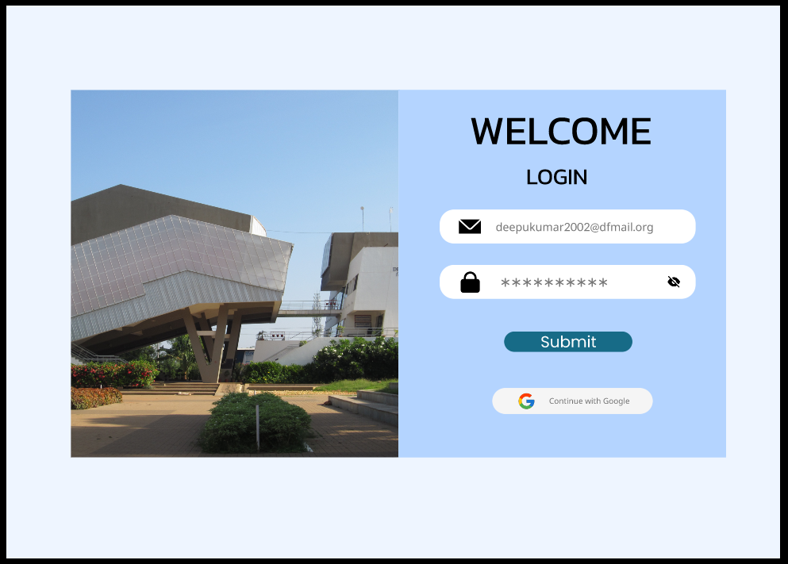

Onclick to “Submit” Button It will be followed to Home Page.

Home Page:

Click The Plus Icon to Open Report Page

Profile

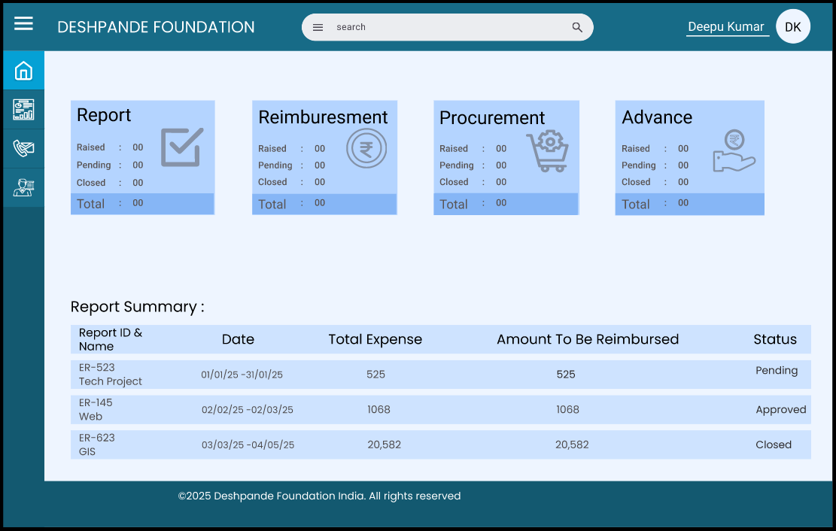

Page

Manger’s

Contact

Us

Report

Home

Onclick to “Report” Button It will be followed to Report page.

Task Page :

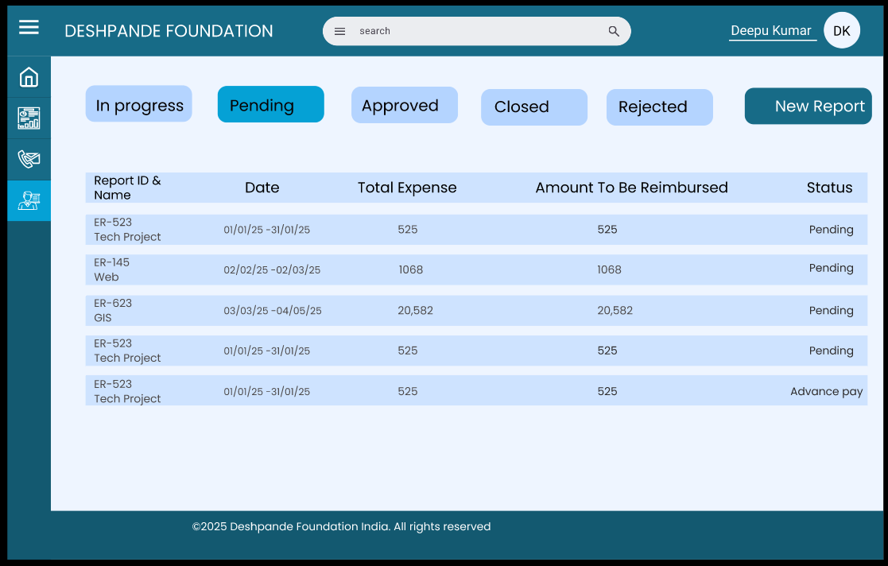

Onclick to “New Report” Button It will be followed to Report Popup.

Report Popup:

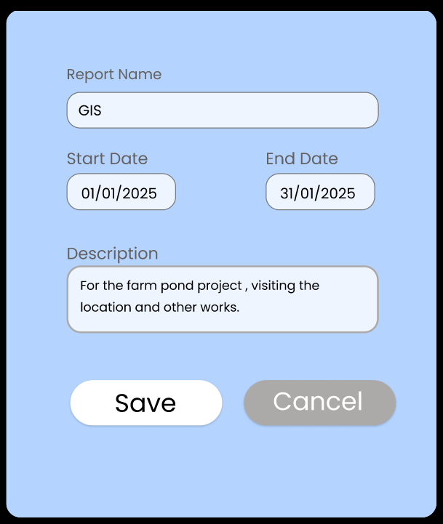

Onclick to “Save” Button It will be followed to Ticket Page.

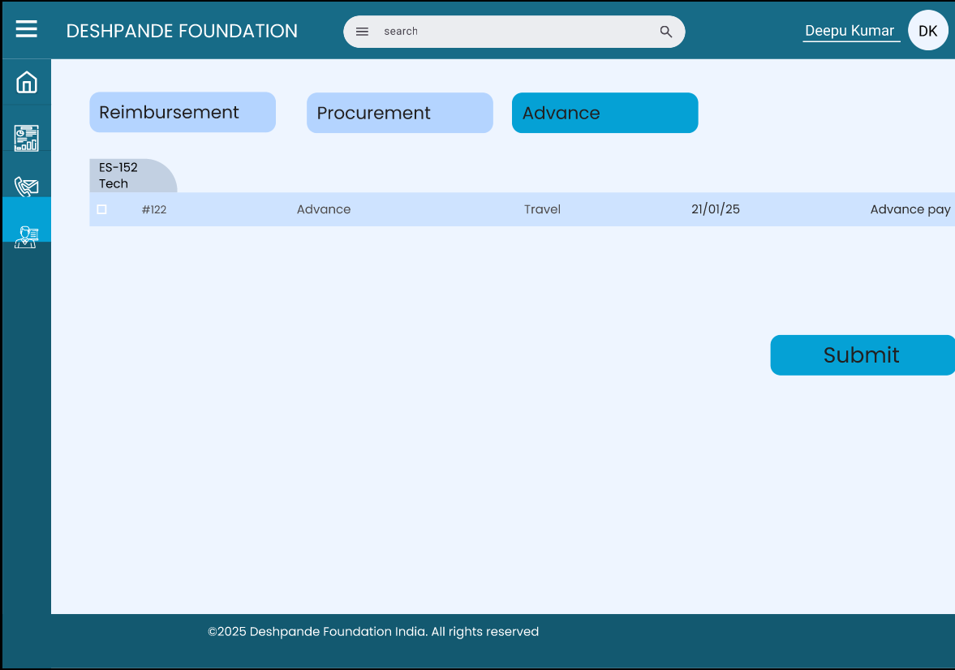Ticket Page:



Types of ticket

Onclick to “Advance” Button It will be followed to Advance Ticket Page.

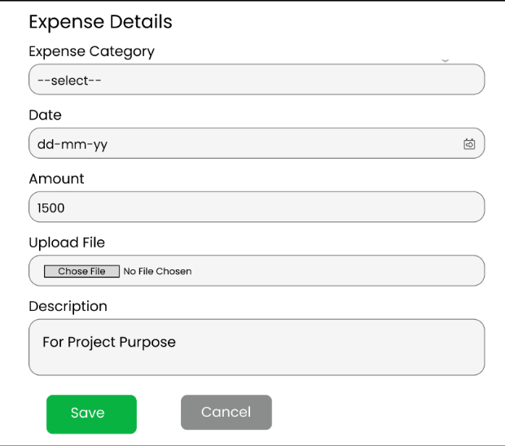

* "Once you fill in the expense details, you can upload a screenshot of the approval from the manager."
* "After submitting all the details, click on the save button to apply for the advance payment."
* "After saving the details, they will be saved in your pending list until the manager approves them."

"After saving the advance request, it will be sent to the manager for approval."

Manager Home Page:



Home

Profile

Employee

Request list

Contact Us

Report

* "Once you click on the Employee Request button, it will show all the raised tickets list."

Employee Request List Page:

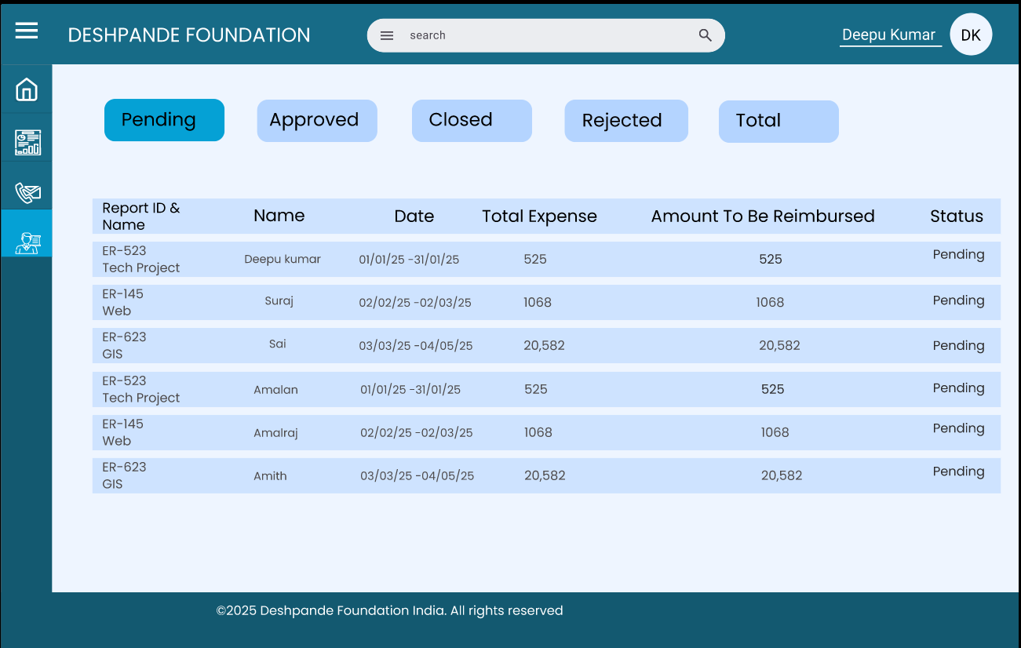

* "You can see different types of request reports, such as Pending, Approved, Closed, Rejected, and Total Reports. This helps you view the reports accordingly."
* "Click on the particular report to view the Advance request in detail."

Employee Request List Detail:

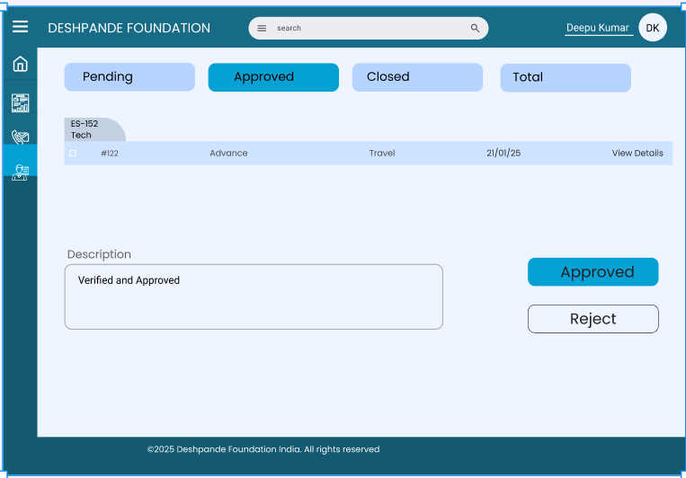

Report I’D &

Name

* "The manager can see the request list, and he can also view the details

by clicking on 'View Details.'"

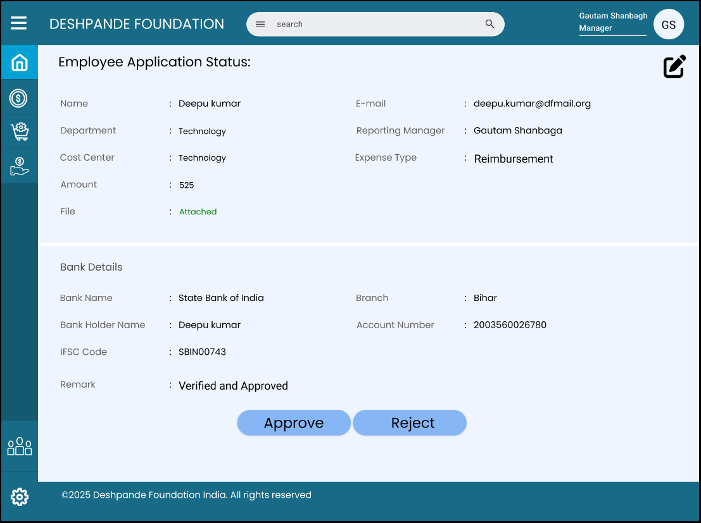

* Manager Can view Full Details of Advance and He can approve particular ticket
* Or Manager can approve Total report also

"Once the manager approves the report or ticket, it is directly sent to the finance team for review and to process the Advance payment."

Finance Team Home Page:

* In Finance team 2 types of process is there:
* "Finance processor – The finance processor can view the details and process the report."
* "Finance Approve – The finance team can approve the report based on the finance processor's review."



Home

Profile

Report

Manager Approve list

Contact Us

* "Once you click on the Manager Approve button, it will show all the approved reports."

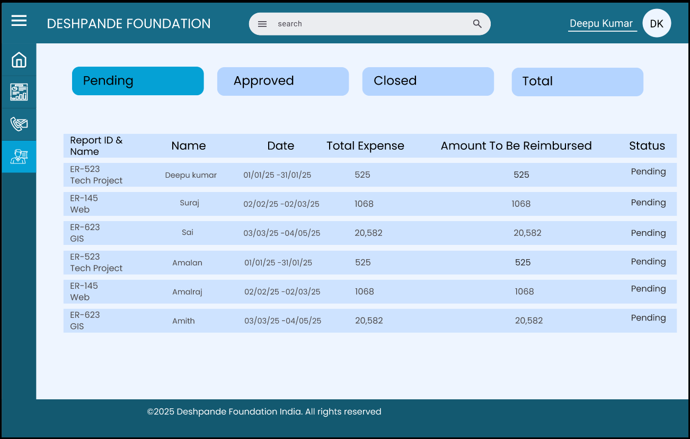

* "Once you click on a particular report, you can see the ticket list."

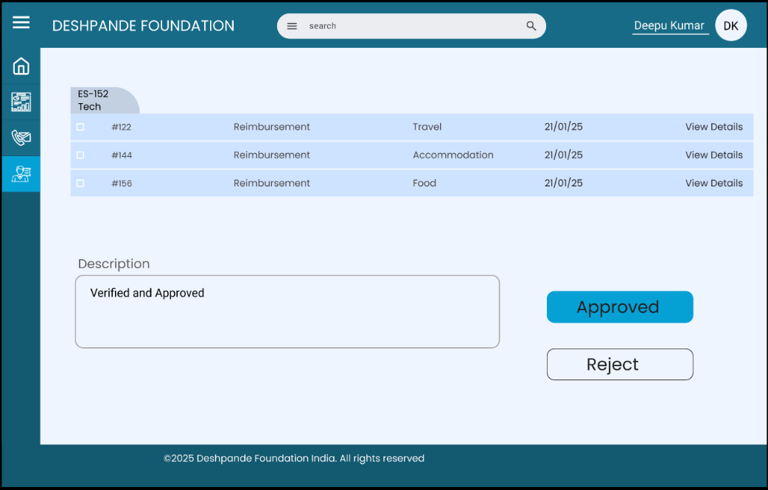

* "Click on the 'View Details' button so the finance team can

view the particular ticket list in detail."

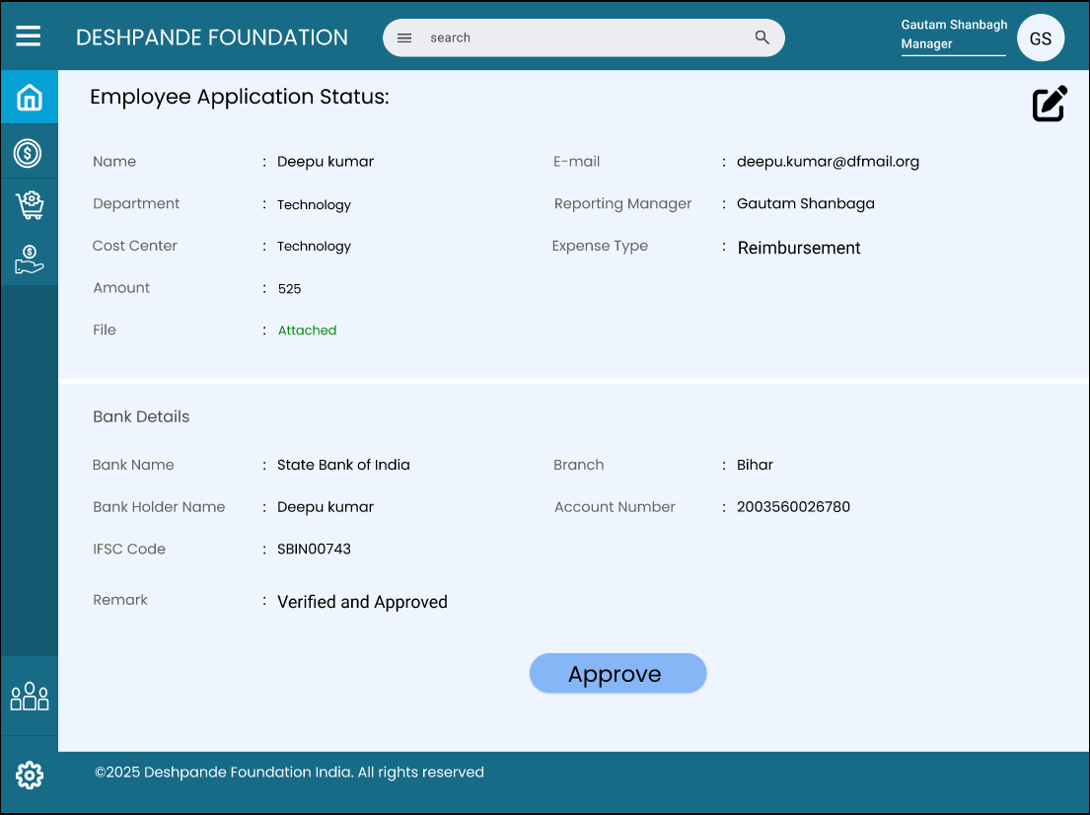

* "Click on the ‘edit button’ so the finance team can edit the ticket."

"The finance team can approve the ticket or report. Once approved, the finance team will save the ticket until Advance Payment Cleared."

**Ticket Closure**

1. **Expense Submission**:
   * After completing the work, the employee submits an expense report.
   * Attaches necessary receipts and justifications for the spent amount.

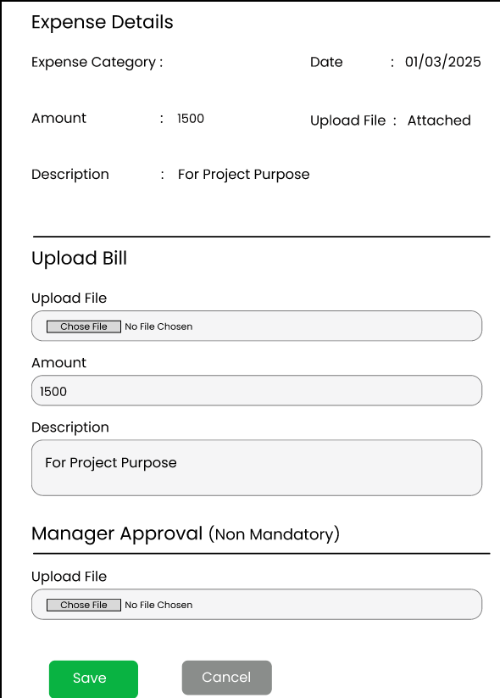

Once the employee fills in the required details, they save the ticket, which is then directly sent to the finance team.

1. **Finance Settlement**:
   * Finance cross-checks the submitted receipts with the advance given.
   * If any balance is due, either the employee returns excess funds or receives reimbursement for additional expenses (if approved).
2. **Ticket Closure**:
   * Once the settlement is confirmed, the ticket is marked as **Closed** in the system.
   * The employee receives a confirmation of closure.

**3. System Notifications**

* **Employee Notifications**: Request submission, approval/rejection, fund disbursement, closure confirmation.
* **Manager Notifications**: Approval requests, expense submission for review.
* **Finance Notifications**: Approved advances for processing, expenses for settlement.

**5. Compliance & Documentation**

* Employees must attach **valid receipts** and **justifications** for expenses.
* Any misuse of advance funds may lead to disciplinary action.
* All approvals and transactions are logged in the DF Ticketing System for audit purposes.